Show Me The Data!
A Comprehensive Approach to
fostering a Data-Driven Culture

(Make a Copy of this document to type into it)

Session Objectives:
- Understand EA’s data-driven framework for application at your school setting

- Leverage the provided tools and resources to adapt within your school setting

- Reflect on current practices and next steps for your school data culture

Cycle of Data Gathering:
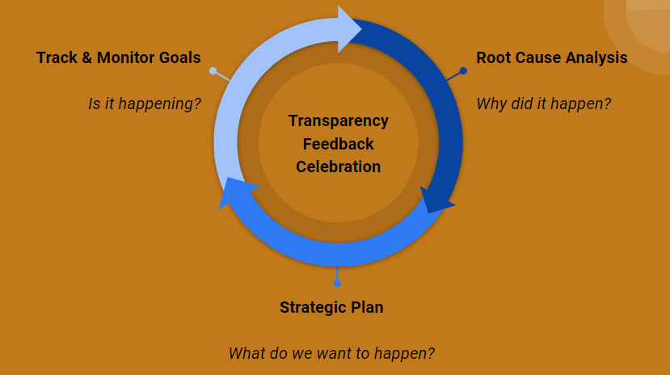

Root Cause Analysis:

Notes:
Resources: | - Root cause document  - Virtual Workspace pages 1 - 6
Reflection: | What is your current level of expertise with root cause analysis?  1 2 3 4 5  novice proficient expert  What would need to happen for you to increase your skill set in this area?  What action steps can you take this school year?

Strategic Plan:

Notes:
Resources: | - Strategic plan document  - Data step back packet (prework)  - Data step back PPT  - Problem statement into an action  - Key questions for smart goals  - Virtual workspace - pages 6 -12
Reflection: | What is your current level of expertise with strategic planning?  1 2 3 4 5  novice proficient expert  What would need to happen for you to increase your skill set in this area?  What action steps can you take this school year?

Track & Monitor Goals:

Notes:
Resources: | - Data Master  - Individual Data Chats  - Data step back packet
Reflection: | What is your current level of expertise with tracking & monitoring goals?  1 2 3 4 5  novice proficient expert  What would need to happen for you to increase your skill set in this area?  What action steps can you take this school year?

Closing Question:
What are your next steps to support a more comprehensive data driven culture at your school?

