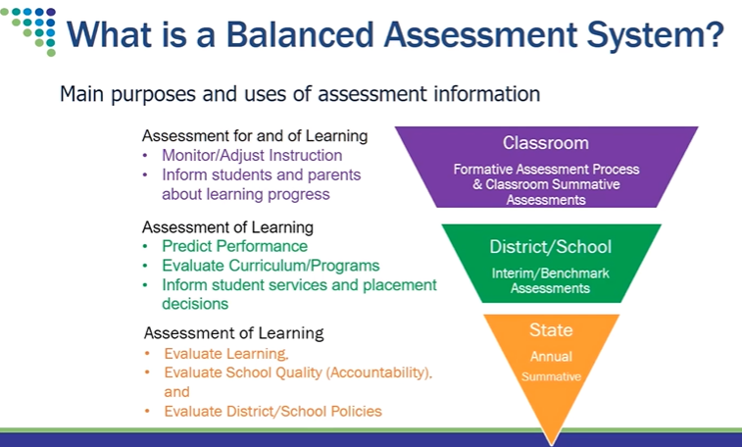

**What strategies can be used in MICIP for each of these components of a Balanced Assessment System?**

**Assessment For Learning in the Classroom:**

What are the expectations of Assessment for learning in the classroom (formative assessment)?

What are your school's activities (action items committed to doing)? (How often, training, etc.)

**Assessment of Learning in the Classroom:**

What are the expectations of Assessment for learning in the classroom (summative assessment)?

What are your school's activities (action items committed to doing)? (How often, training, etc.)

**Assessment of Learning at the school/district level:**

What are the expectations of Assessment for learning at the district/school level?

**Keep this in mind….**

1. Teachers- Did enough students learn what I taught them? What feedback did I provide?
2. Teachers- What do I put in the grade book? On the report card?
3. Teachers- What additional learning is needed?
4. Students- How well did I do? How can I do better?

What are your school's activities (action items committed to doing)? (How often, training, etc.)

**Assessment of Learning at the State Level:**

1. Are enough students proficient?
2. How did sub-groups perform?

How does the school/district utilize state data for instruction and curriculum reviews?

What are your school's activities (action items committed to doing)? (How often, training, etc.)